Abeeb Ayodeji

aayodeji@umd.edu

INFM600

Dr. Wiggins

Processing Documentation

Step 1. First, I opened both the “Food Establishment” and “Parks” CSV spreadsheets.

Step 2. Then I copied the “FID” cells in the “Parks” spreadsheet and pasted it under the last cell in the “FID” section of the “Food Establishment spreadsheet.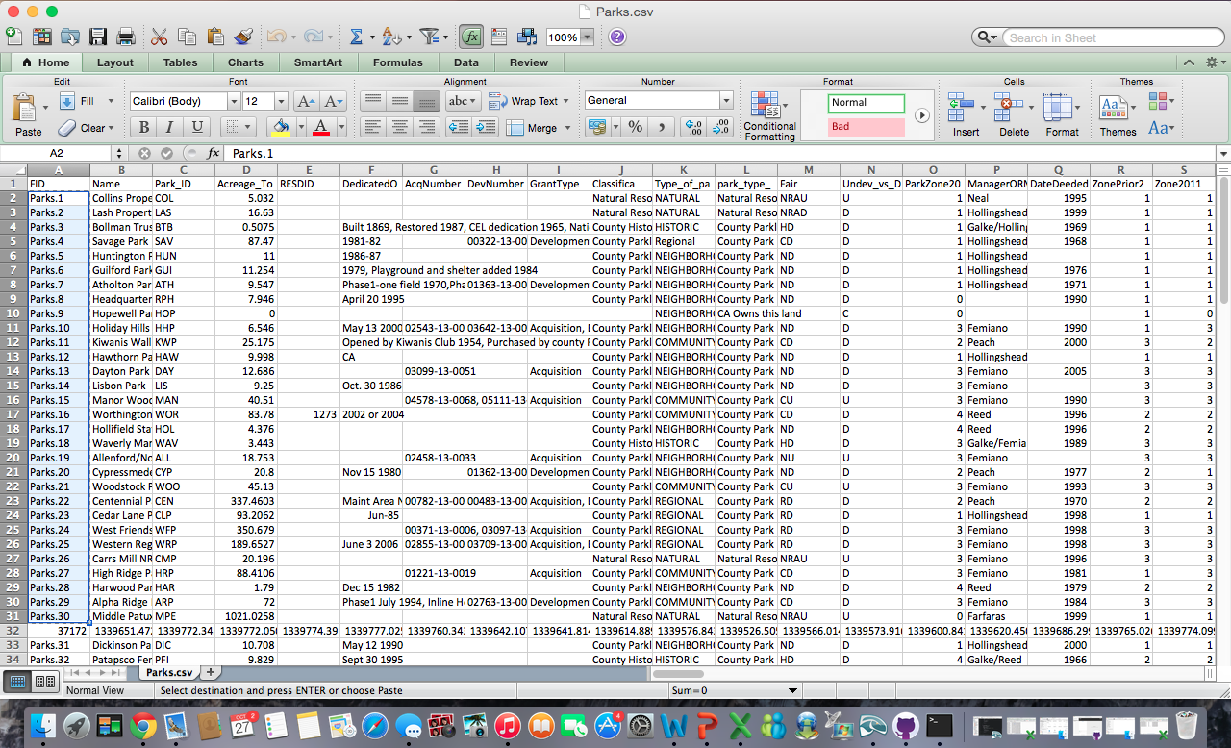

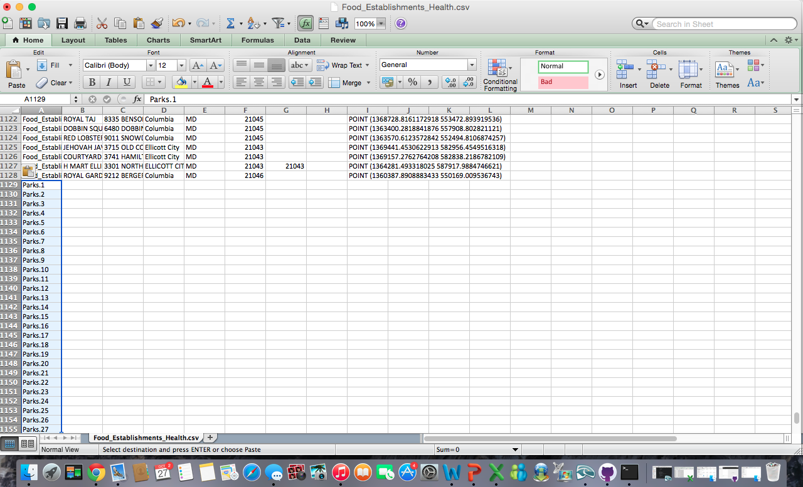

Step 3. I repeated the second step for the “Name”, “Address”, “City”, “State”, “Zip Code” and “goem” cells. I copied the cells from each of these sections in the “Parks” spreadsheet and pasted them under the matching sections in the “Food Establishment” spread sheet.

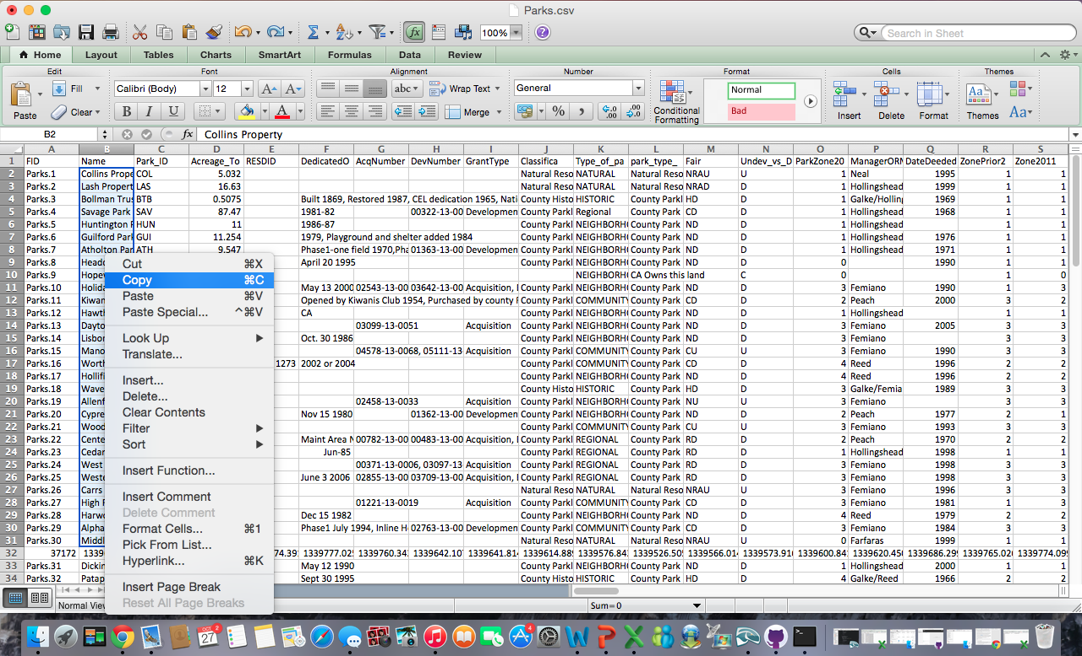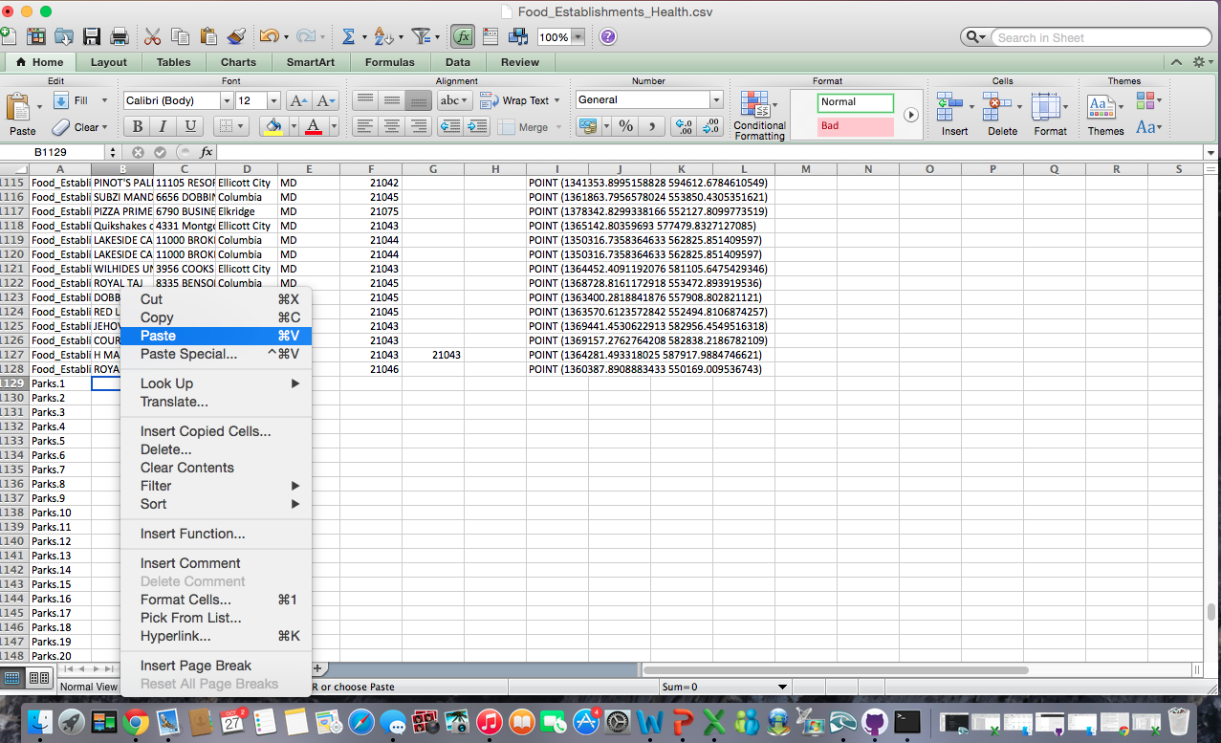

*In order to find the “Address”, “Zip Code”, “City”, “State” and “geom” sections, I scrolled to the right in the “Parks” spreadsheet. I simply dragged one “MD” cell down for every park “Sate” cell because Howard County is located in Maryland.

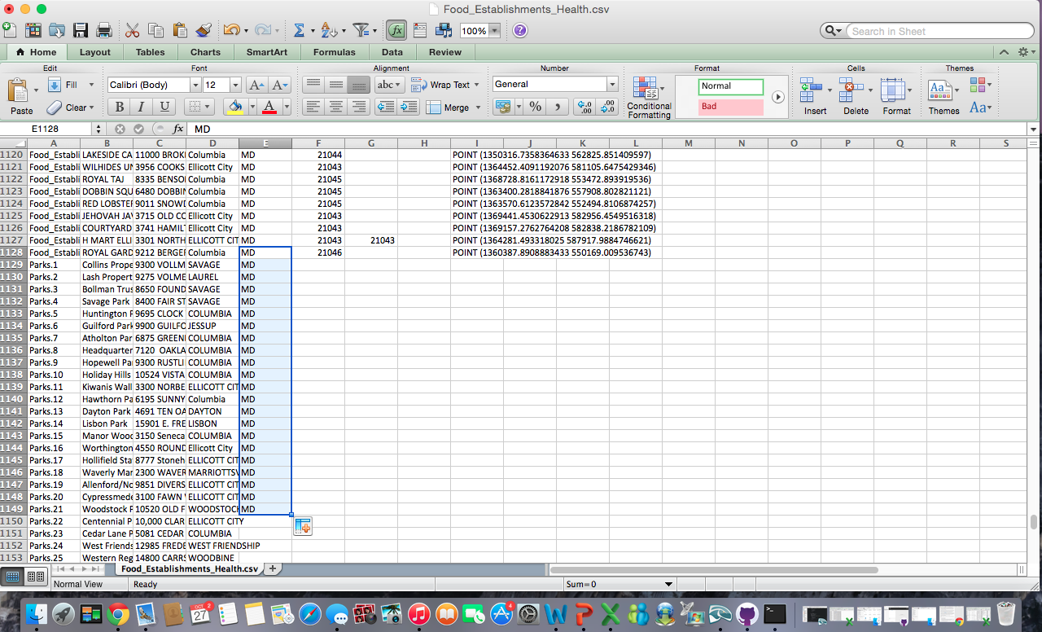

Step 4. I highlighted the “FID” entries of every park in yellow, in order to facilitate differentiation. In order to do this, I selected all the “FID” park cells and then clicked the “Fill Color” button located underneath the font size button.

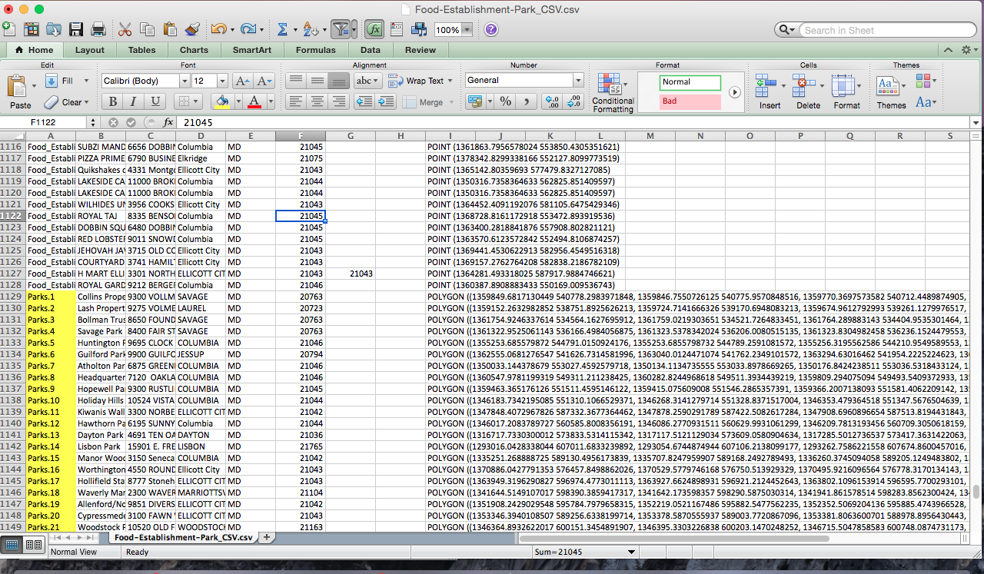

Step 5. Then, I organized every Food Establishment and Park by city. I accomplished this by clicking cell “D”, which selects every “City” cell in the spreadsheet. After selecting every “City” cell, I clicked the “Filter” button that is located on the tool bar at the top of the window. I clicked the “A-Z” option, which puts every city in alphabetical order.

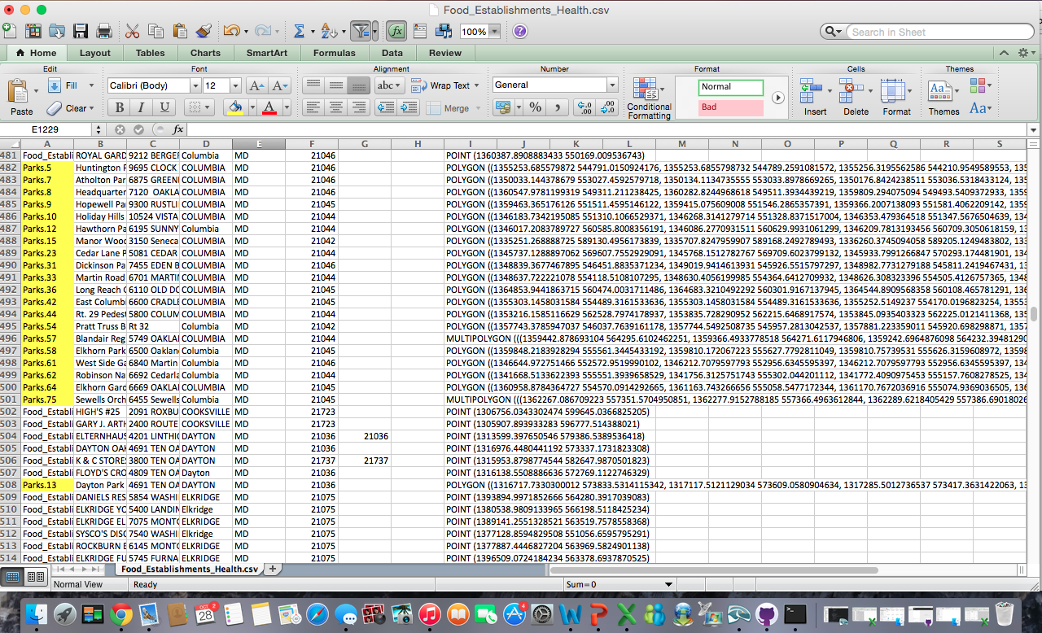

Step 6. Finally, I scrolled to the “File” tab and clicked the “Save as” option, which allowed me to save my new spreadsheet as “FoodEstablishment-Park_CSV”.

